**SPH3U 11.3 Electric Potential Difference**

1. **Electric potential difference**

|  |  |
| --- | --- |
| Electric potential: |  |
| Electric potential difference: |  |
| equation |  |
| Quantity of electrons: |  |

Calculate the electric potential difference between the negative and positive terminals of a battery if 1500 J of electric potential energy is transformed to move 125 C of charge between the terminals.

1. **Series and parallel circuits**

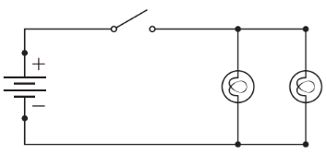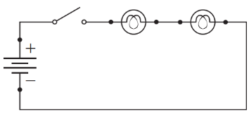

|  |  |
| --- | --- |
| Series circuit: |  |
| Parallel circuit: |  |
| Voltmeter: |  |

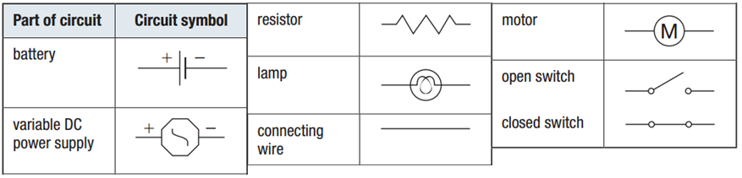

**Homework:** page 513: #1-5, 7